Nama : Abdi Akhsanul Afkar

NIM : 18090048

Kelas : 5C

PRAKTEK W1

1. Code

Perkenalan.php - application/controller

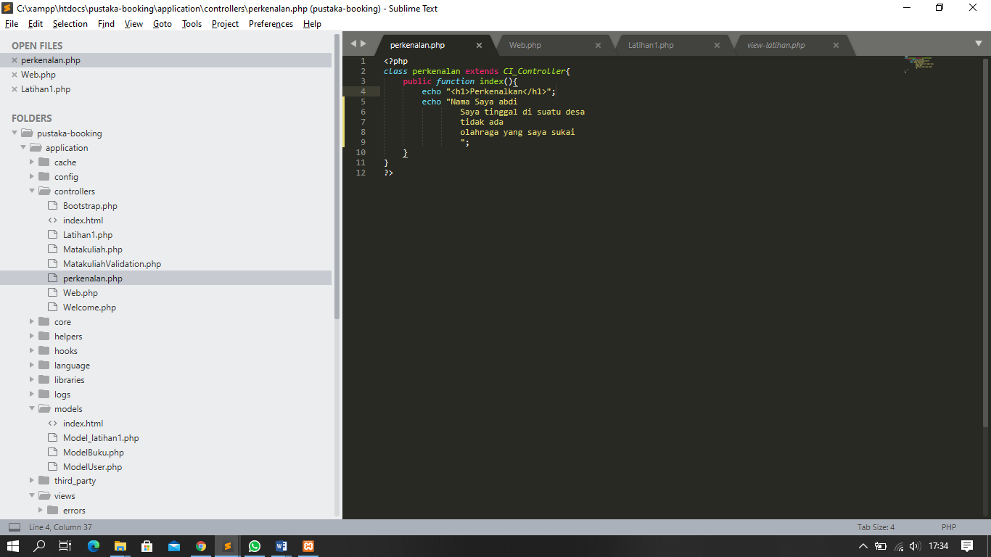

1. URL

<http://localhost/pustaka-booking/perkenalan>

1. Screenshot